**The Ark Documentation.**

**Biospecimen search.**

Log in and select your study.

To search for an existing biospecimen, click on the Biospecimen Search function.

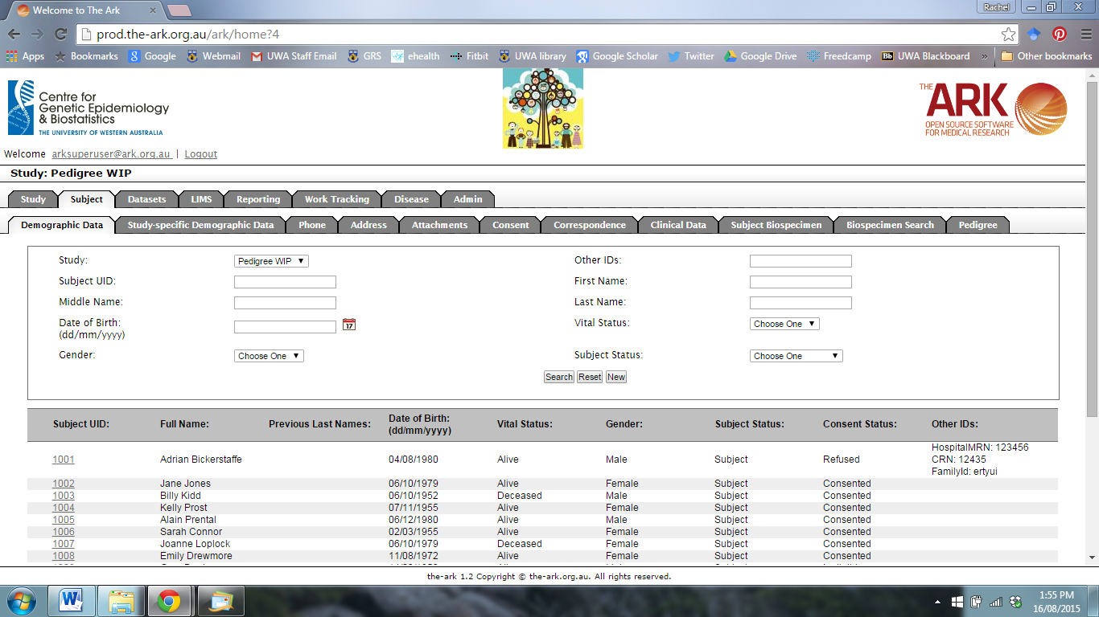

The following page will appear.

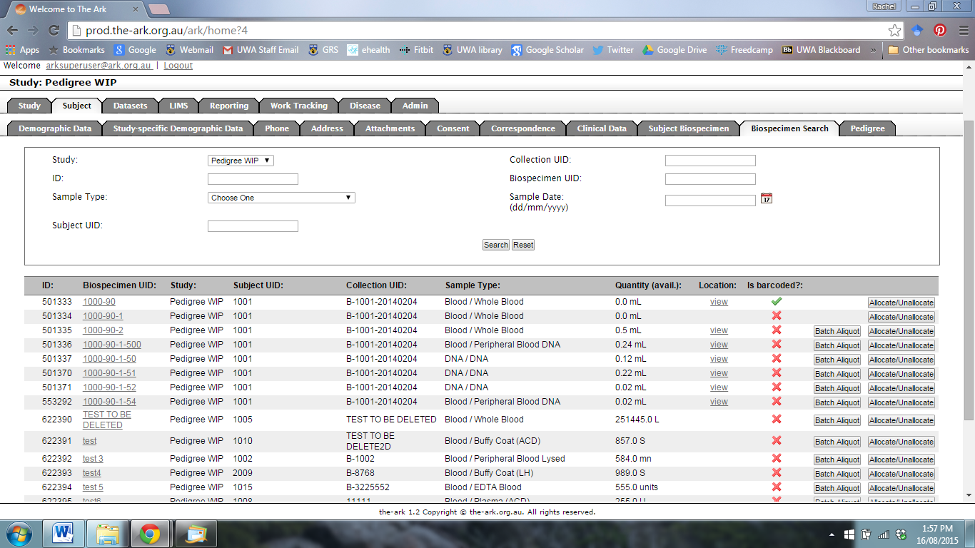

You can search by

1. Sample Type
2. Subject UID
3. Collection UID
4. Biospecimen UID
5. Sample Date

Click search.

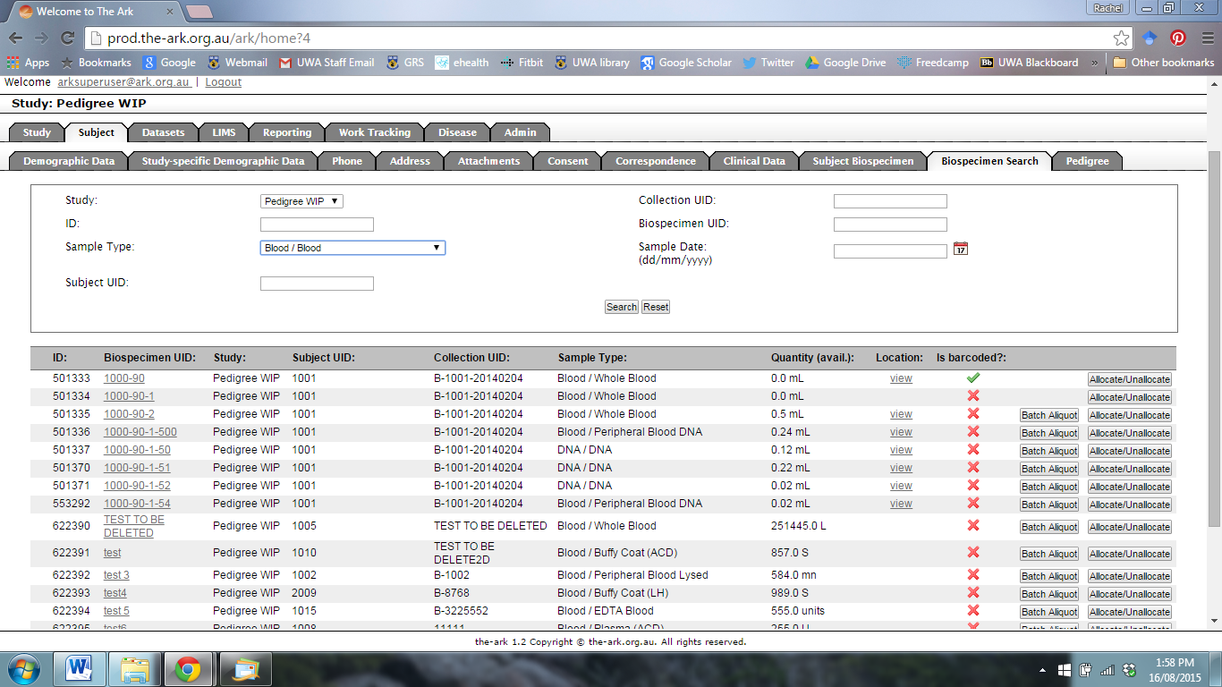

The following page will appear that shows results that match your search terms.

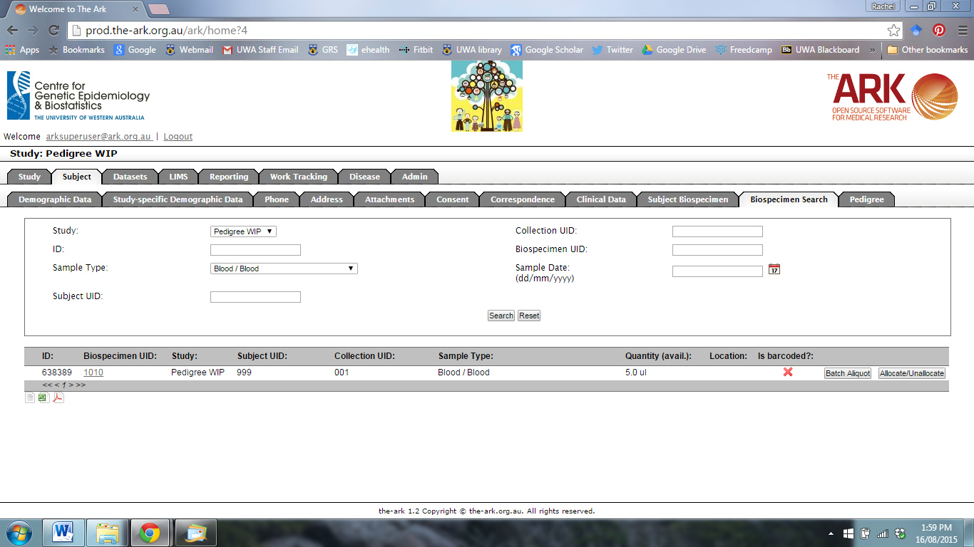

Click on the Biospecimen UID that you wish to view or edit.